Define a Input Variable

We just make main.tf & write multipul resource block & each block has argument like, filename = “/root/pets.txt” content = “hi” , prefix = “Mrs”, separator = “.”, length = “1” etc.

This is what ? We define a variable with it’s value in this main.tf file
This is called HardCoded Value.
This is not good idea.

Like, ansible – roles, we create a separate VARIABLE file where all variable has value . Like that, we will make here separate variable file called variable.tf

In this file – we define all variable & it’s value.
We will call this variable value in main.tf file from this variable.tf file.
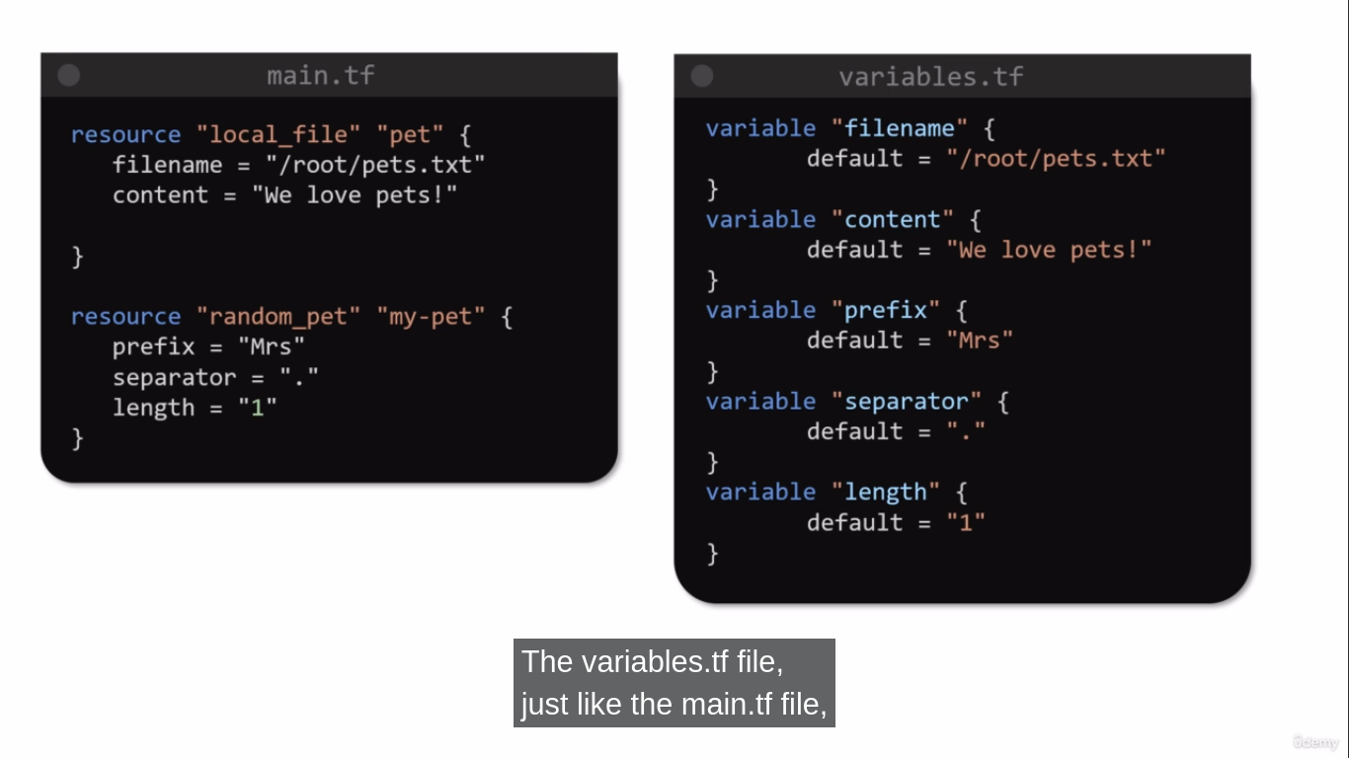

In Variable.tf file

To create a variable – use keyword called variable & define a variable name.
Ex. variable “filename” – filename is a variable name.

In this block { } - define default value of variable name.
Ex. variable “filename” {
default = “/root/pets.txt”
}

Now, How to use Variable value in out main.tf file from variable.tf file ?

Ex. Filename = var.filename
NOTE:- To call variable value we don’t use “ ” .
Now, Do terraform init to terraform apply to create resource by using variable.tf file.

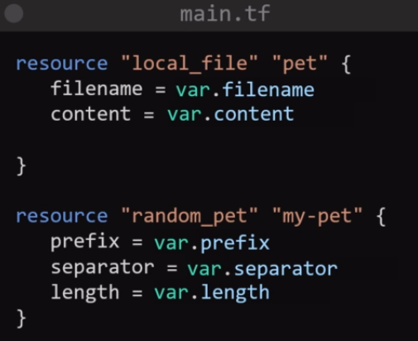

To Modify the resources WE JUST GO TO variable.tf file & MODIFY.
We Don’t have to modify main.tf.
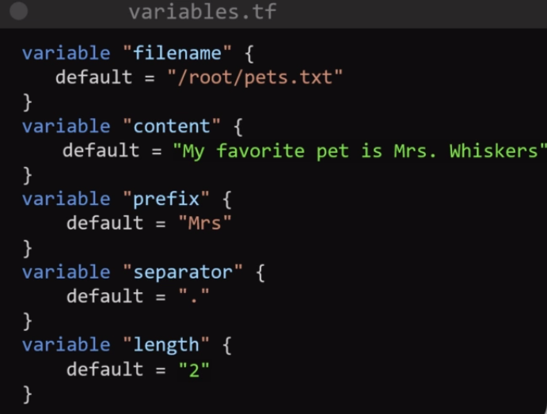
To Modify variable value-

Go to variable.tf file

Change like this.

Now, create resource by terraform init to terrafom apply.

EXAMPLE OF EC2 CREATE USING variable.tf file

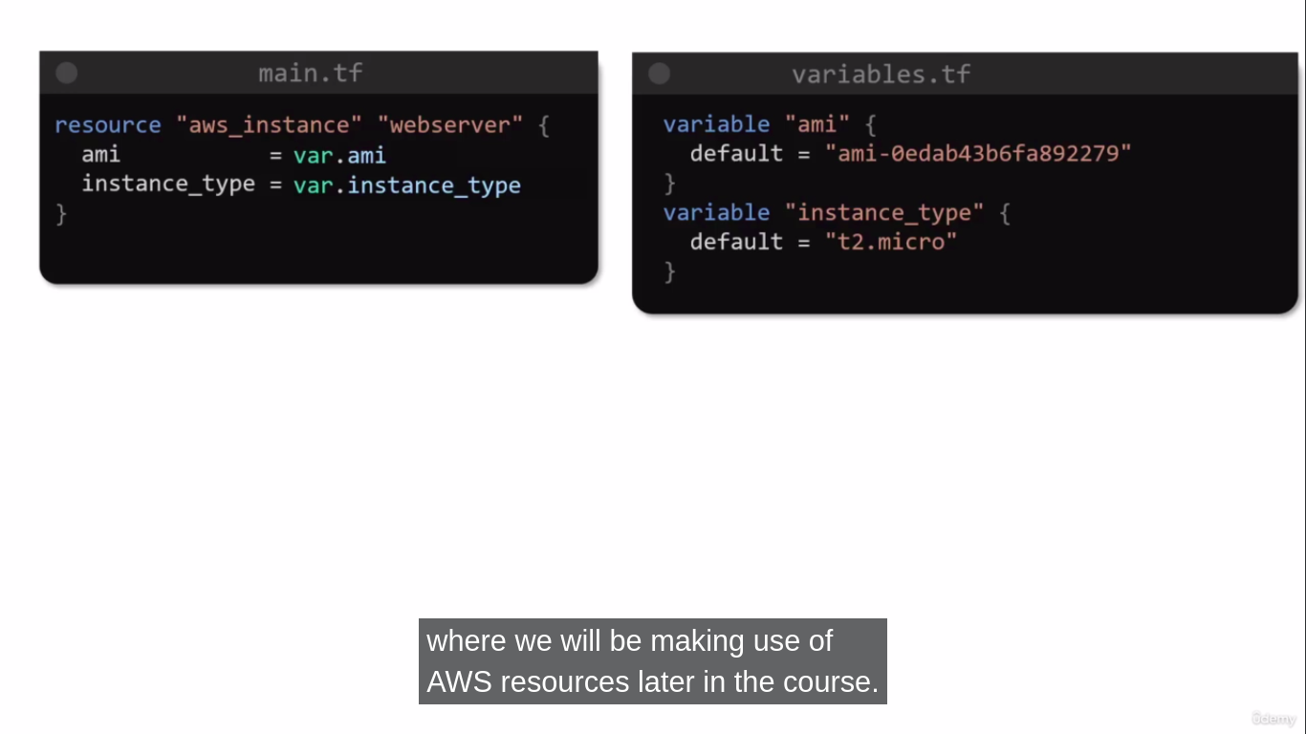

Close Look Into Variable.file
The Variable blcok access 3 Parameters.
1. Default Parameters – We specify the default value of variable
2. Type Parameters – Variable types like string, number, integer, float, bool etc.
3. Description Parameters – This is optional to use, but this is a best practice to use descriptioin parameters to describe what the variable to use.
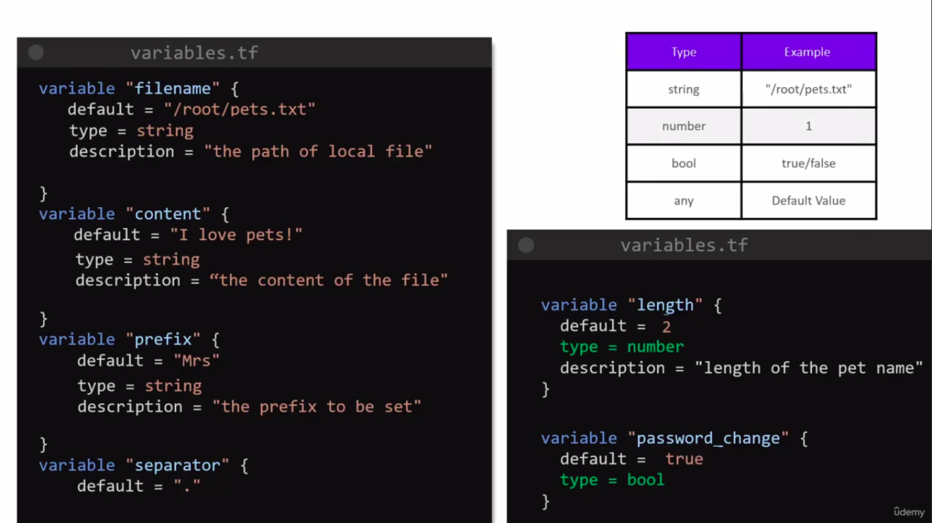
In Below case , we didn’t define any type for variable, so , bydefault it is set to TYPE of ANY.

Terraform supports additional types such as
list , map, object, tuple.

list is a numbered collection of values

Varaible – list
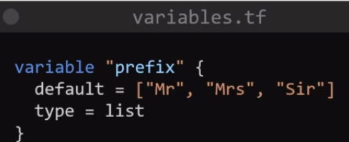
In this example, the variable is “prefix” that uses list of values [“Mr” , “Mrs” , “Sir” ]. This vaules have it’s element value.
Ex. [“Mr”, “Mrs”, “Sir”] -- [ 0 , 1 , 2 ]
Mr have element number 0,
Mrs have element numbet 1,
Sir have element number 2.
To print value of prefix variable – list (Mr)
Resource “rendom_pet” “my-pet” {
Prefix = var.prefix[o]
}

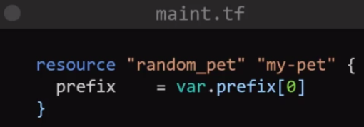

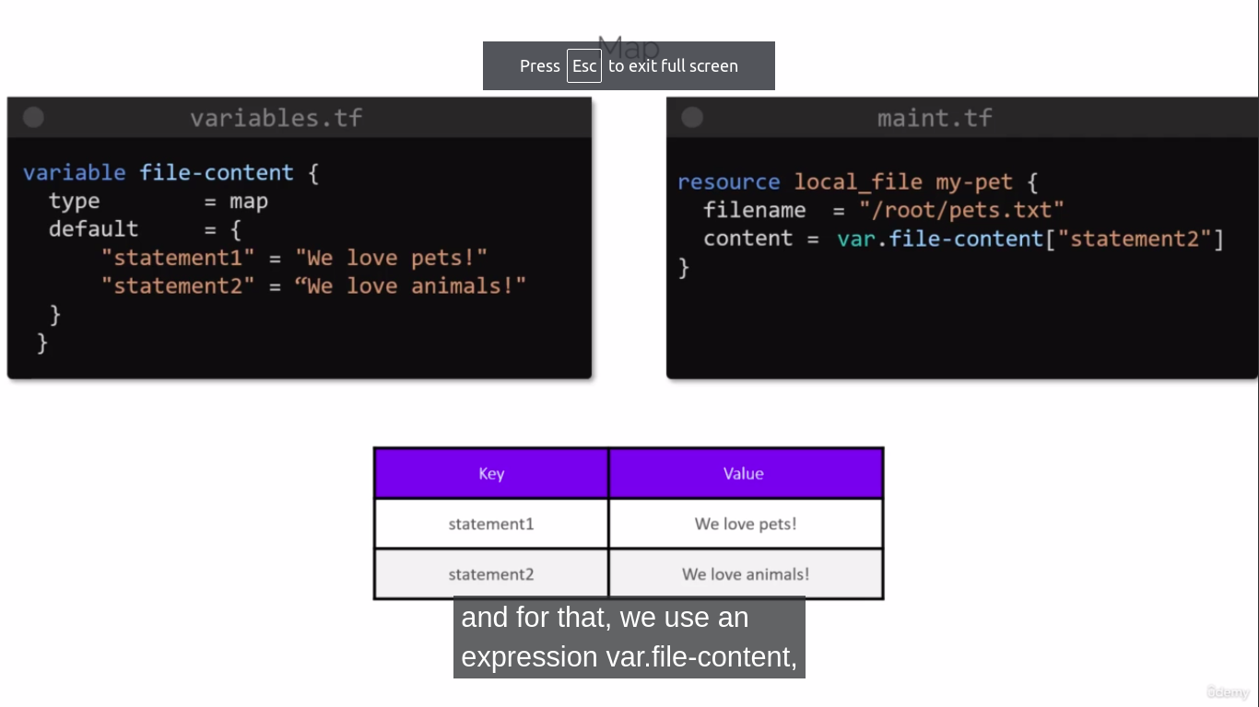
Vairable – map
Map is a data represented in key & value pairs.
In “default” argument, we defined map (key-pair) value.
It indicate type of variable is map.
To call second value of map value into main.tf, by , var.file-content[“statement2”]

Variable – map – String Variable – map – Number
Variable.tf

Variable “cats” {
Default = {
“color” = “brown”
“name” = “bella”
}
Type = map(string)
}
Variable.tf

Variable “cats” {
Default = {
“color” = “brown”
“name” = “bella”
}
Type = map(string)
}
Variable.tf

Variable “pet_count” {
Default = {
“dogs” = 3
“cats” = 1
“goldfish” = 2
}
Type = map(number)
}

Varible -- set
Set doesn’t have similar value. It is similar like list.

variable.tf

variable “prefix” {
default = [“Mrs”, “Mr”, “Sir” ]
type =set(string)
}
variable.tf

variable “age” {
default = [10, 12, 15 ]
type =set(number)
}

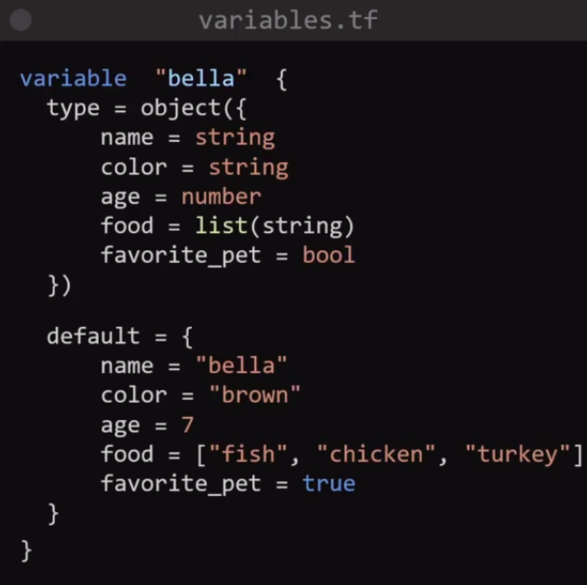
Variable – Objects
We can create complex data/structure by combining all the variable types above.

Variable – tuples
We can use different types of variables by tuples.
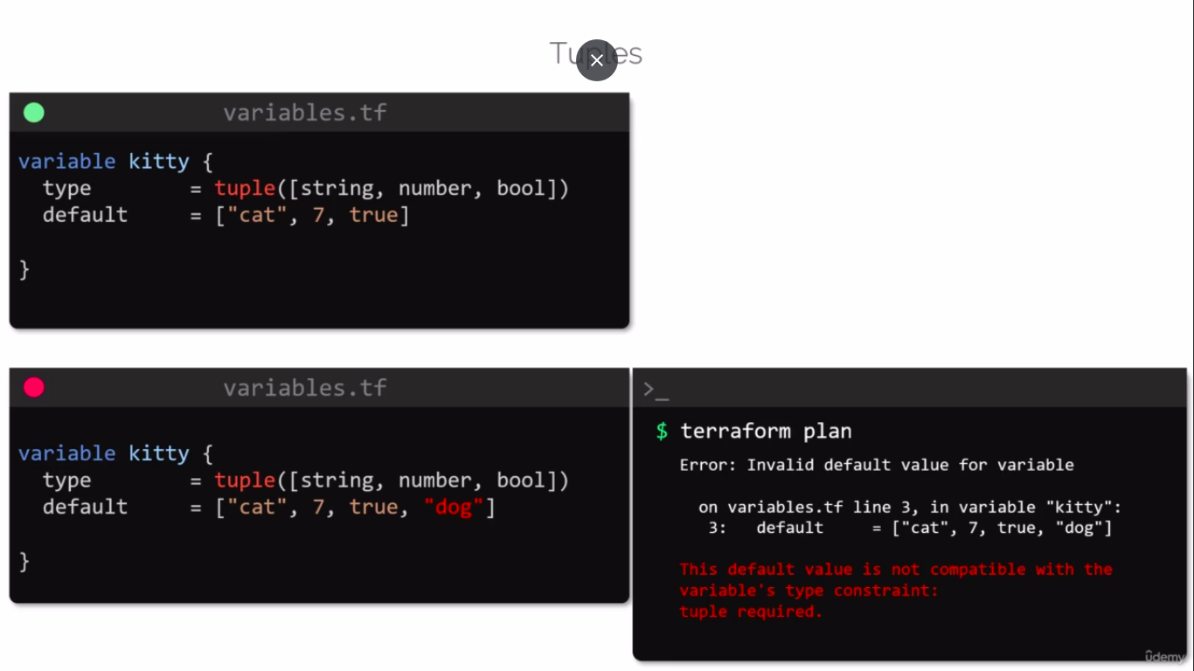

If you defines types of variables like string , number , bool .
It’s value like “cat”, 7, “dog” – it will set to respect to string, number, bool

cat – string Right.
7 – number Right.
Dog – bool Wrong. Here, bool value shoulg be true or false. Not string – Dog.
So, terraform will get you error.

